Lab 4.2

Refer to Tutorial 3: Designing a Page Layout

1. Complete Session 3.2 **pages HTML 208 to HTML 236**

Add a screenshot of the **pc_home.html** file displayed in a browser after completing Step 3 on page HTML 233. Include the browser address bar. Refer to Figure 3-57 for reference

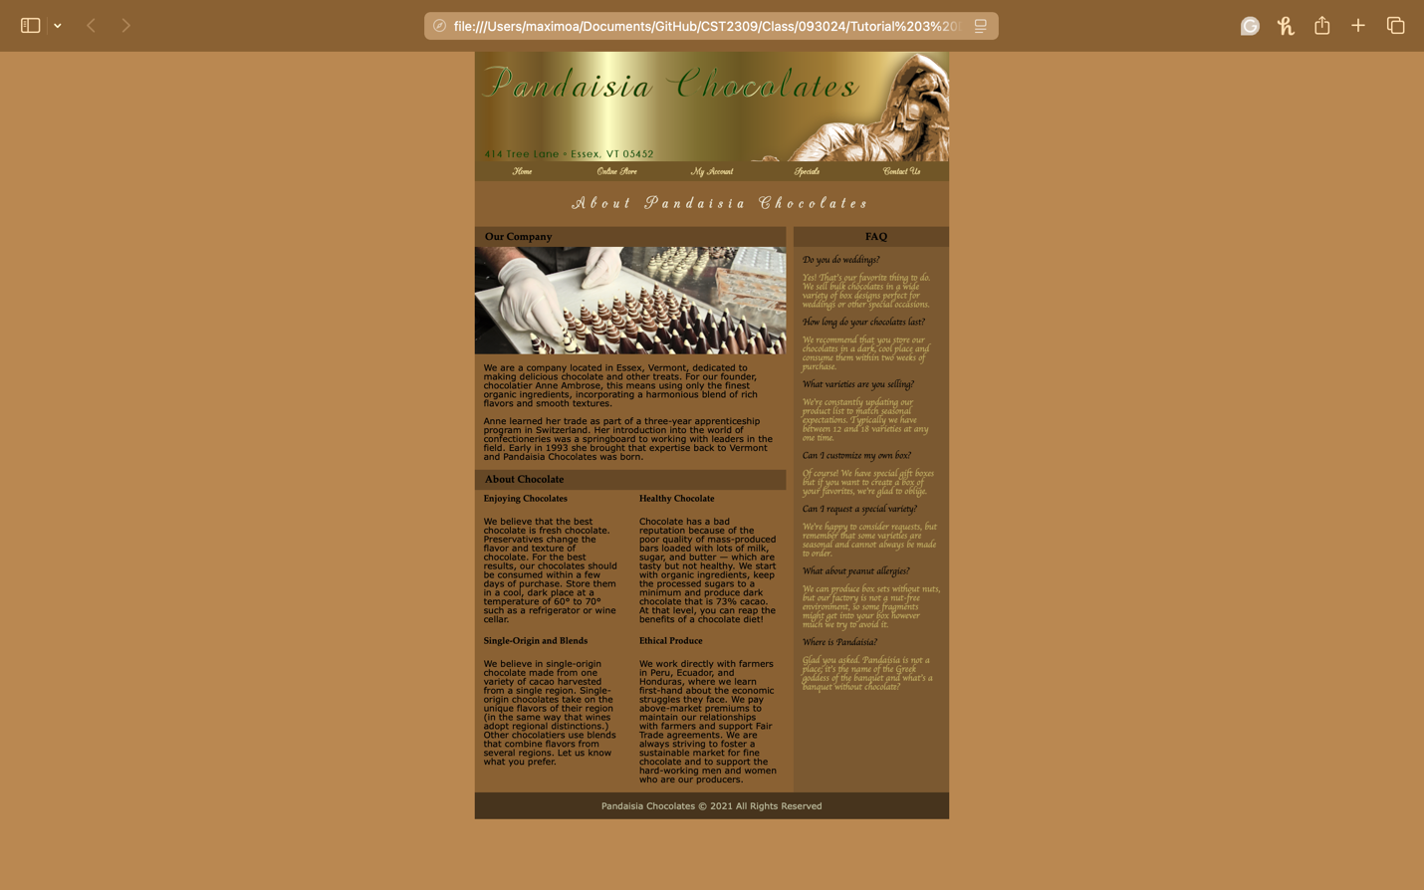

1. Complete the Session 3.2 Quick Check in Blackboard